Do You Qualify for the Idaho Food Stamp Program?

Are you eligible to receive food stamps?
In addition to meeting other characteristics, households may be eligible to participate in the Food Stamp Program if their income is below the following income limits:

Household Size | Gross Monthly Income (130% of federal poverty guideline)
1 | $ 1,287
2 | 1,736
3 | 2,184
4 | 2,633
5 | 3,081
6 | 3,530
7 | 3,980
8 | 4,430
Each additional household member | + 451
*Accurate gross monthly income limits as of October 1st, 2016

Idahoans who receive TAFI, SSI or ABBD are automatically income-eligible to receive food stamps.

To apply for the Idaho Food Stamp Program, visit your local Department of Health and Welfare office, or access an application at http://healthandwelfare.idaho.gov/.

Fact or Fiction? Myths about Access to the Food Stamp Program

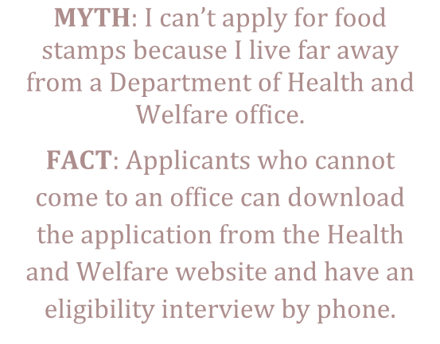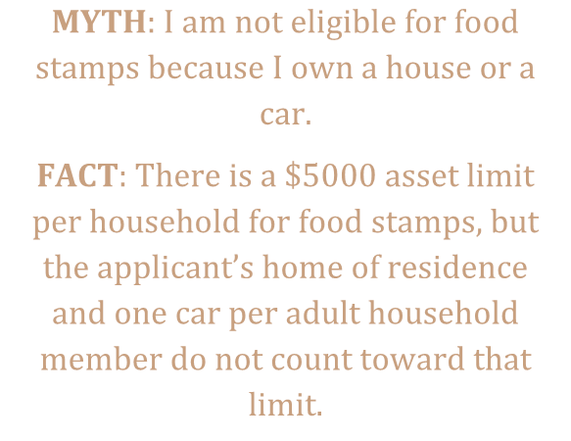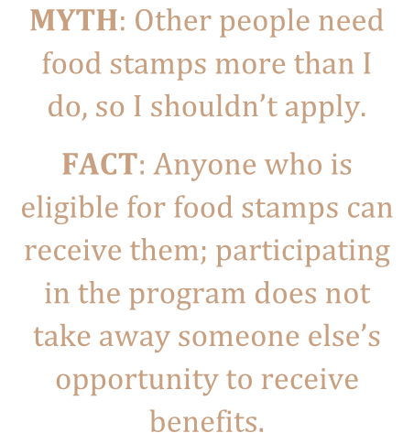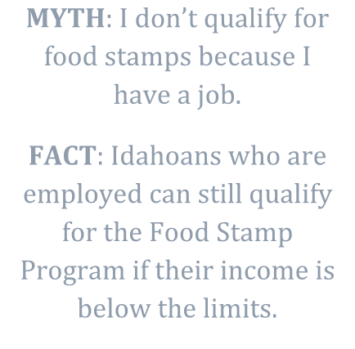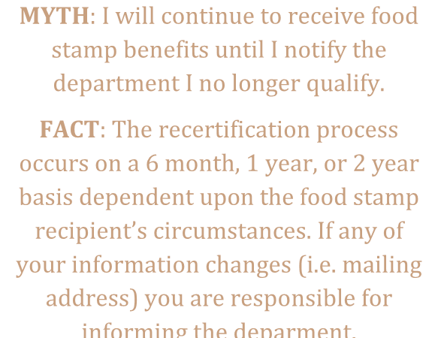

MYTH
I
:
can’t apply
for food
stamps because
I live far away
from a Department of Health and
Welfare office.

FACT
:
Applicants
who cannot
come to an office can download
the
application from the H
ealth
and Welfare website and have an
eligibility interview by

phone.

MYTH
I am not eligible for food
:
stamps because I own a house or a
car.

FACT
There is a $5000
:
asset limit
per household for food stamps, but
the applicant’s home of residence
and one car per adult household
member do not count toward that
limit.

MYTH
:
O
ther people need
food stamps more than I
do, so I shouldn’t apply.

FACT
Anyone who is
:
eligible for food stamps can
receive them; participating
in the program does not
take away someone else’s
opportunity to receive
benefits.

MYTH
:
I don’t qualify for
f
ood stamps because I
have a job.

FACT
:
Idahoans who are
employed can still qualify
for the Food Stamp
Program if their income is
below the limits.

MYTH
:
I will continue to receive food
stamp benefits until I notify the
department I no longer qualif
y.

FACT
:
The recertification process
occurs on a 6 month, 1 year, or 2 year
basis dependent upon the food stamp
recipient’s circumstances. If any of
your information changes (i.e. mailing
address) you are responsible for
informing the deparment.

For more information about applying for the Idaho Food Stamp Program, call 2-1-1 or visit the website of the Idaho Department of Health and Welfare, http://healthandwelfare.idaho.gov/.

